**Problem 41 of chap.2**

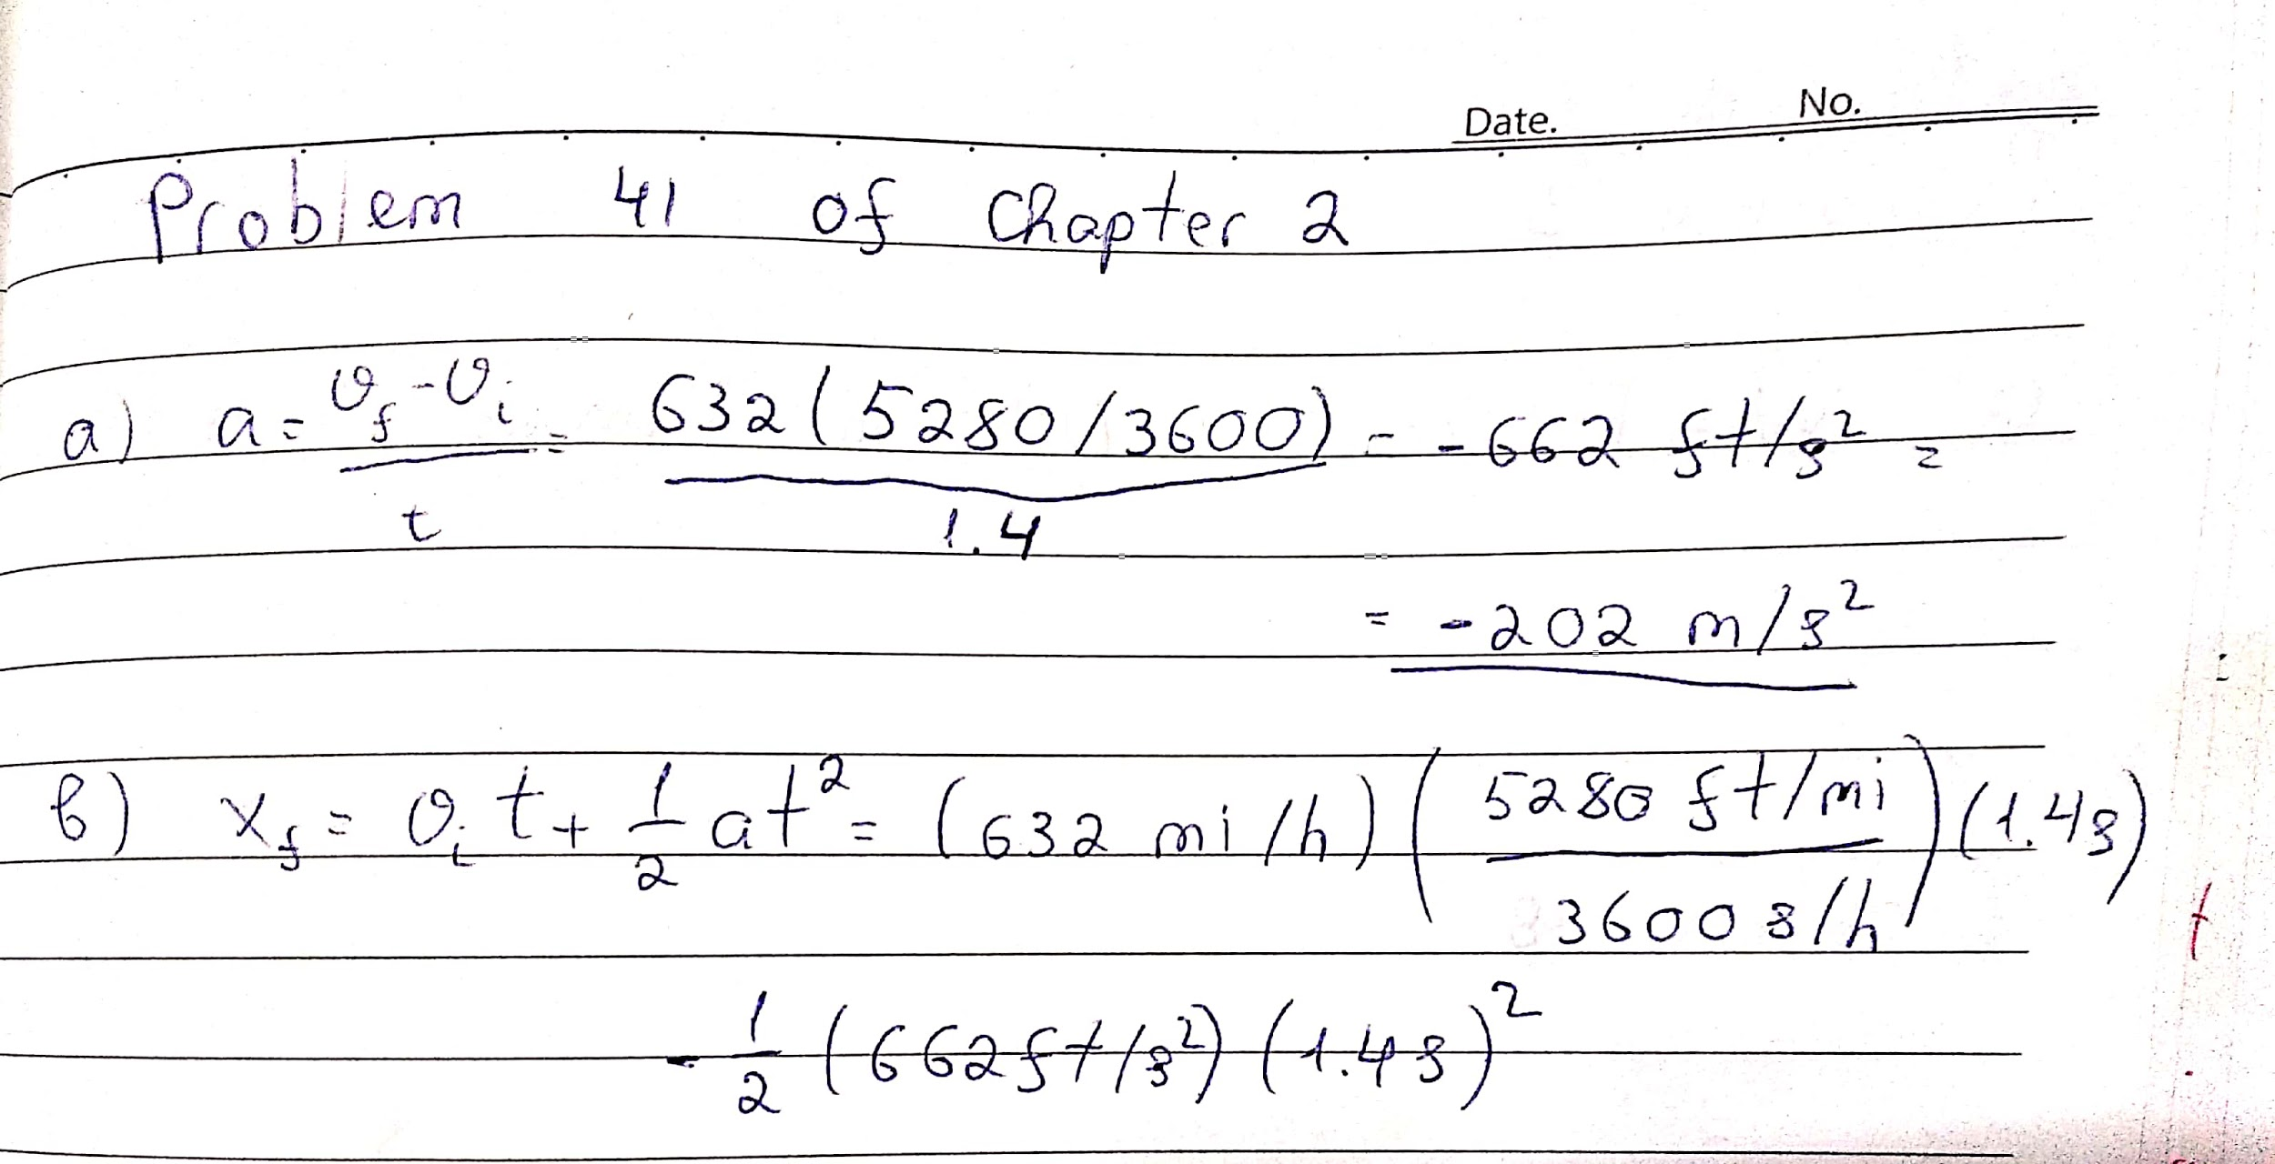

**Problem 48 of chap.3**

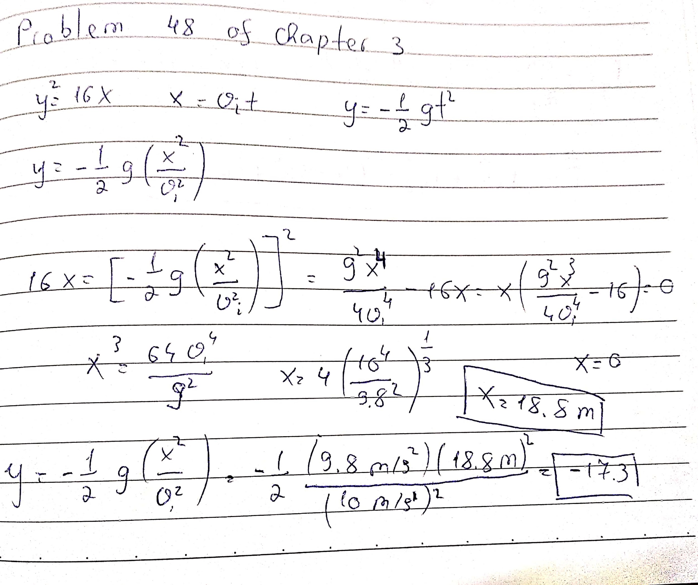

**Problem 24 of chap.4**

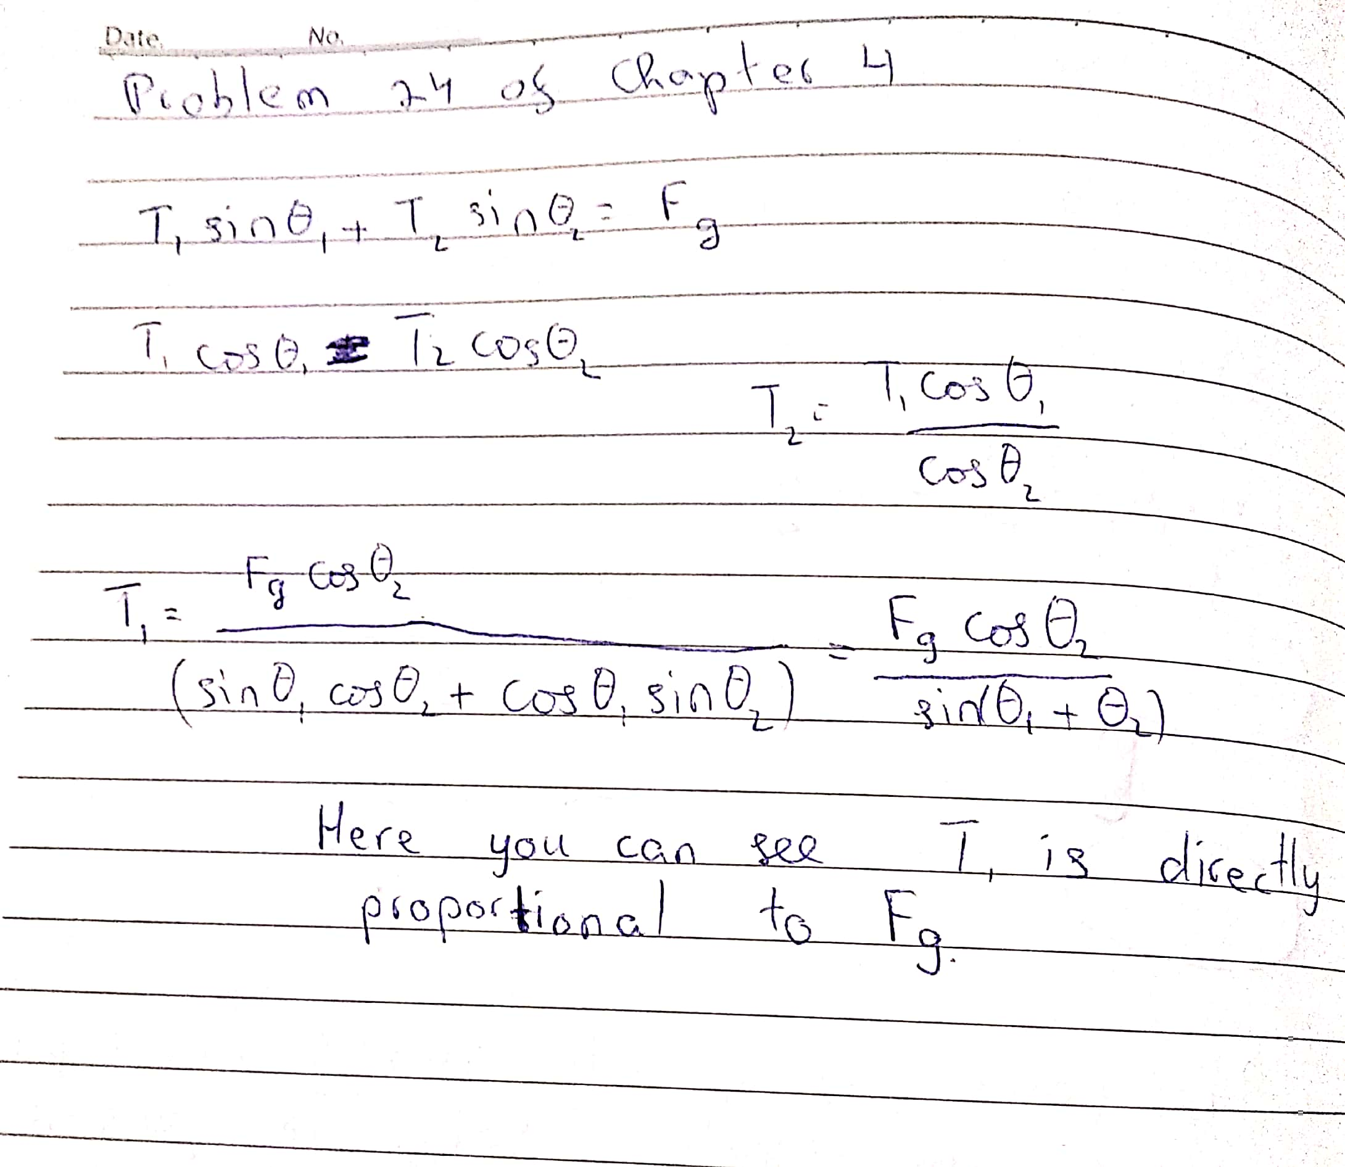

**Problem 60 of chap.5**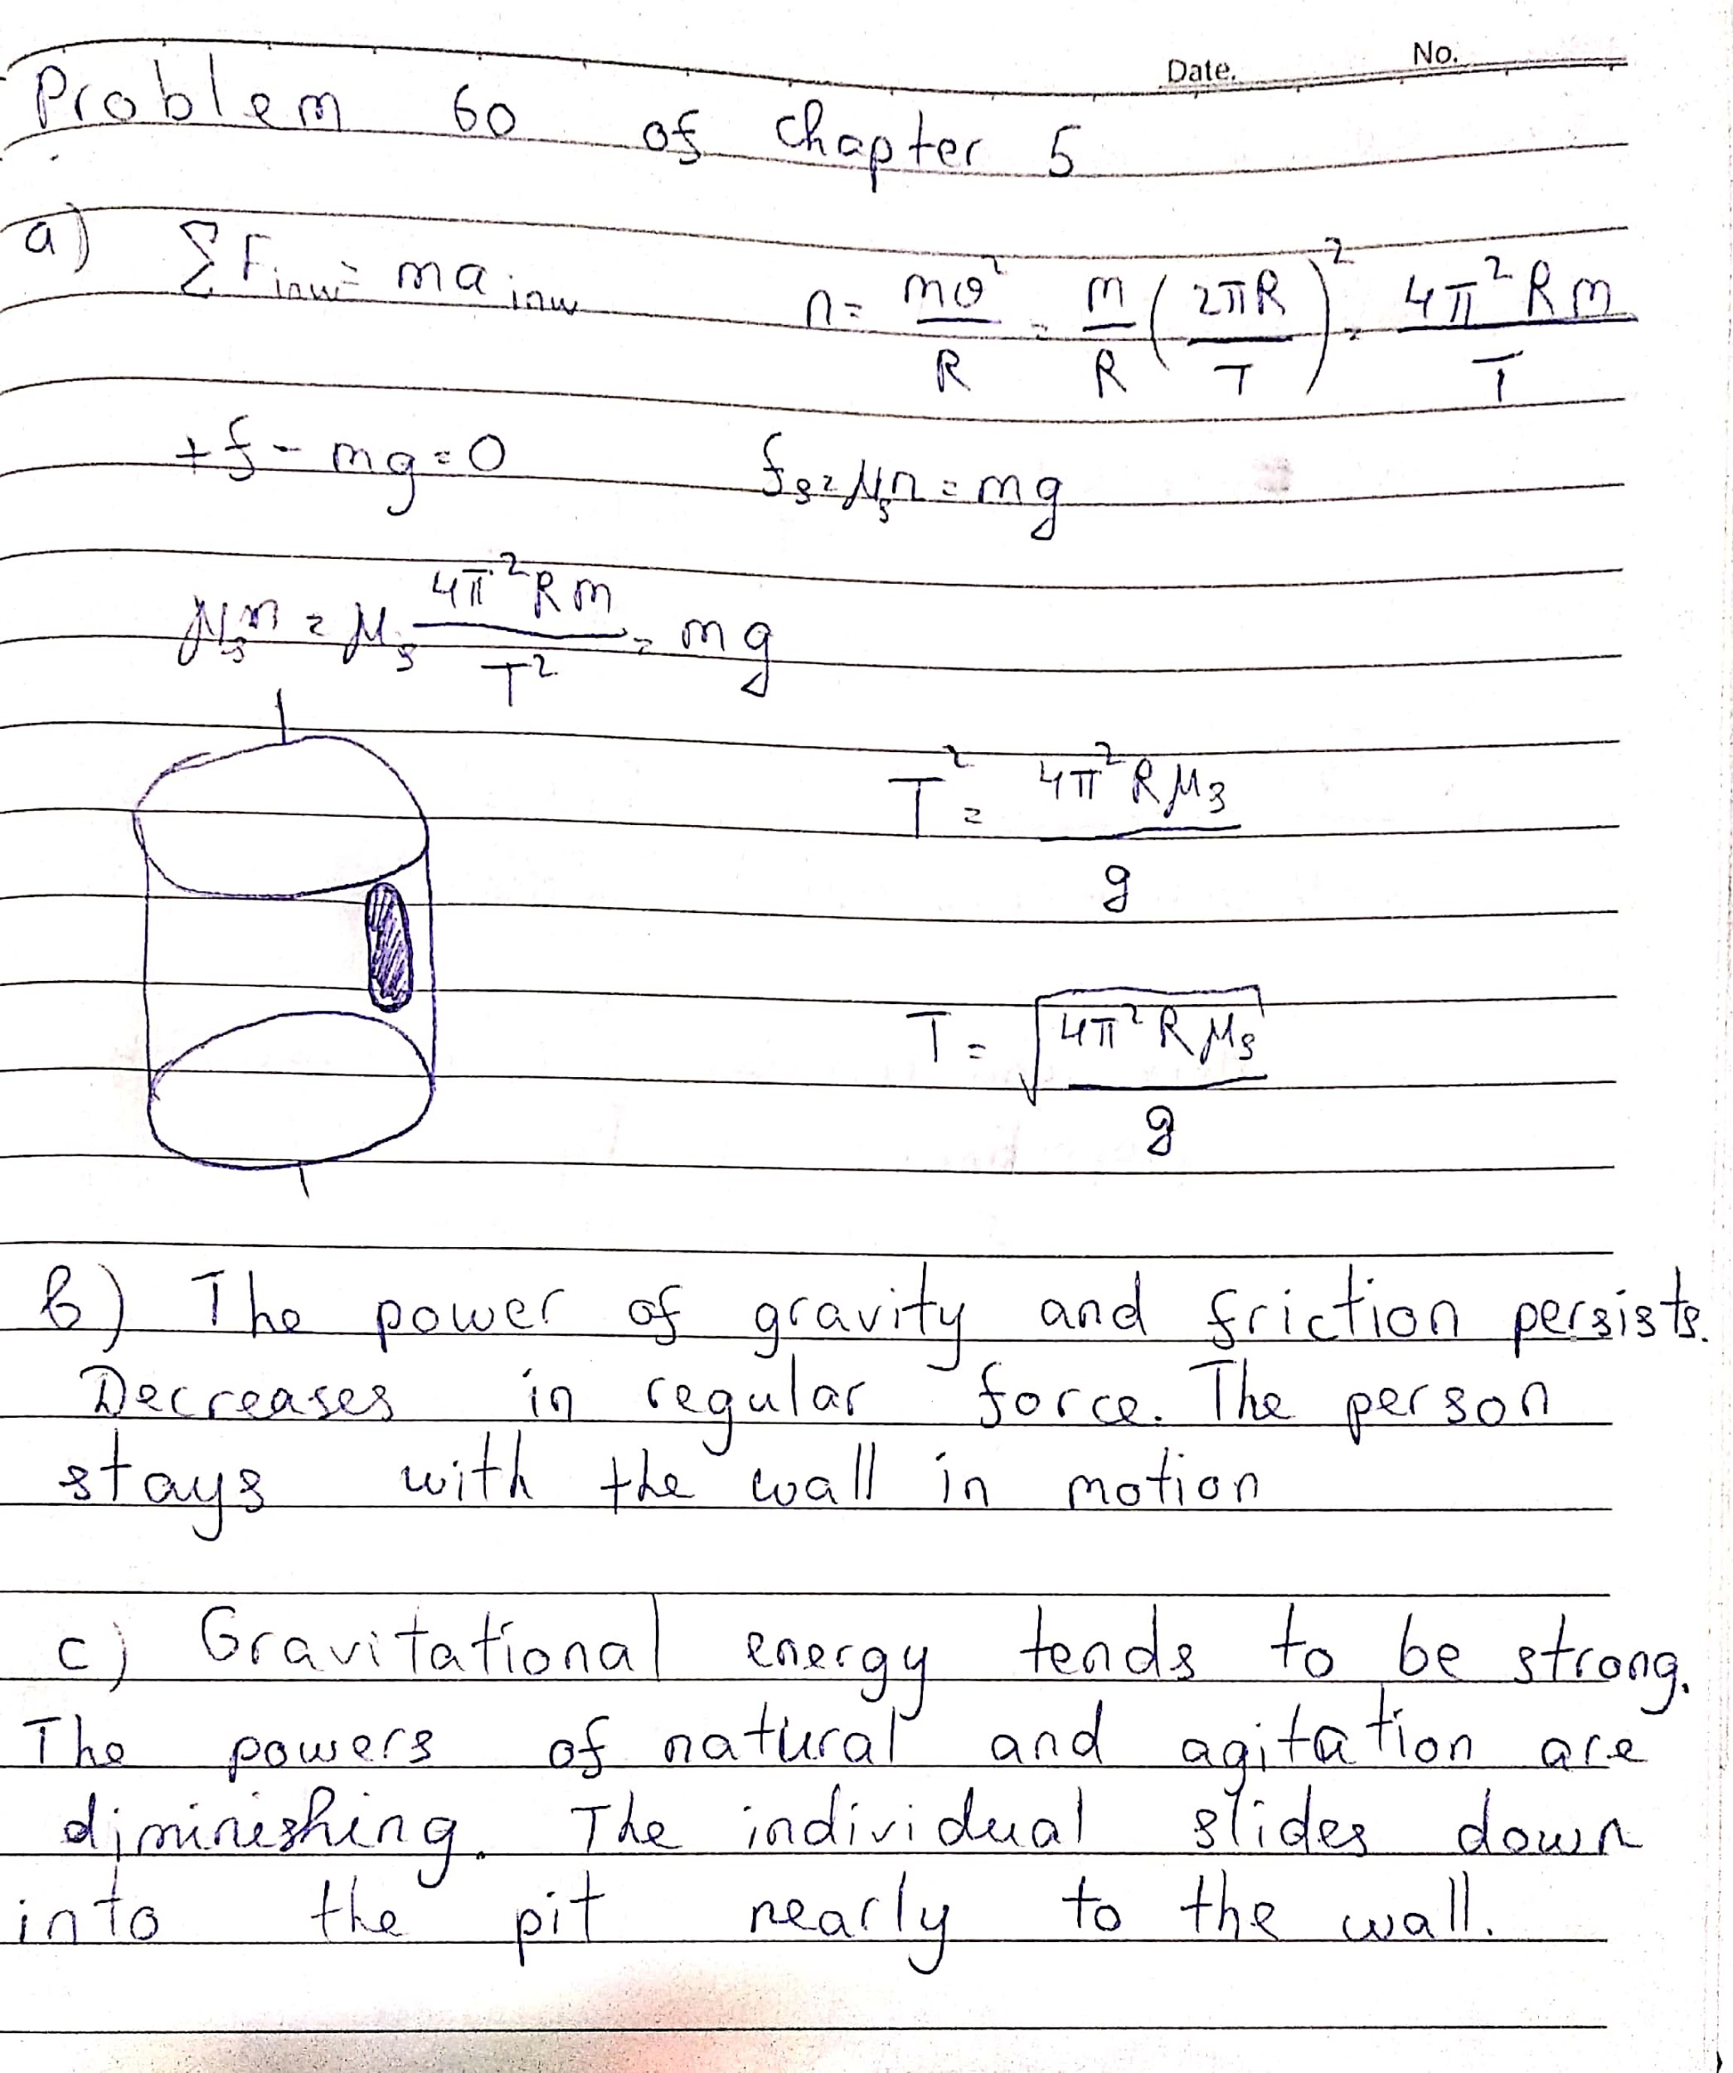

**Problem 61 of chap.6**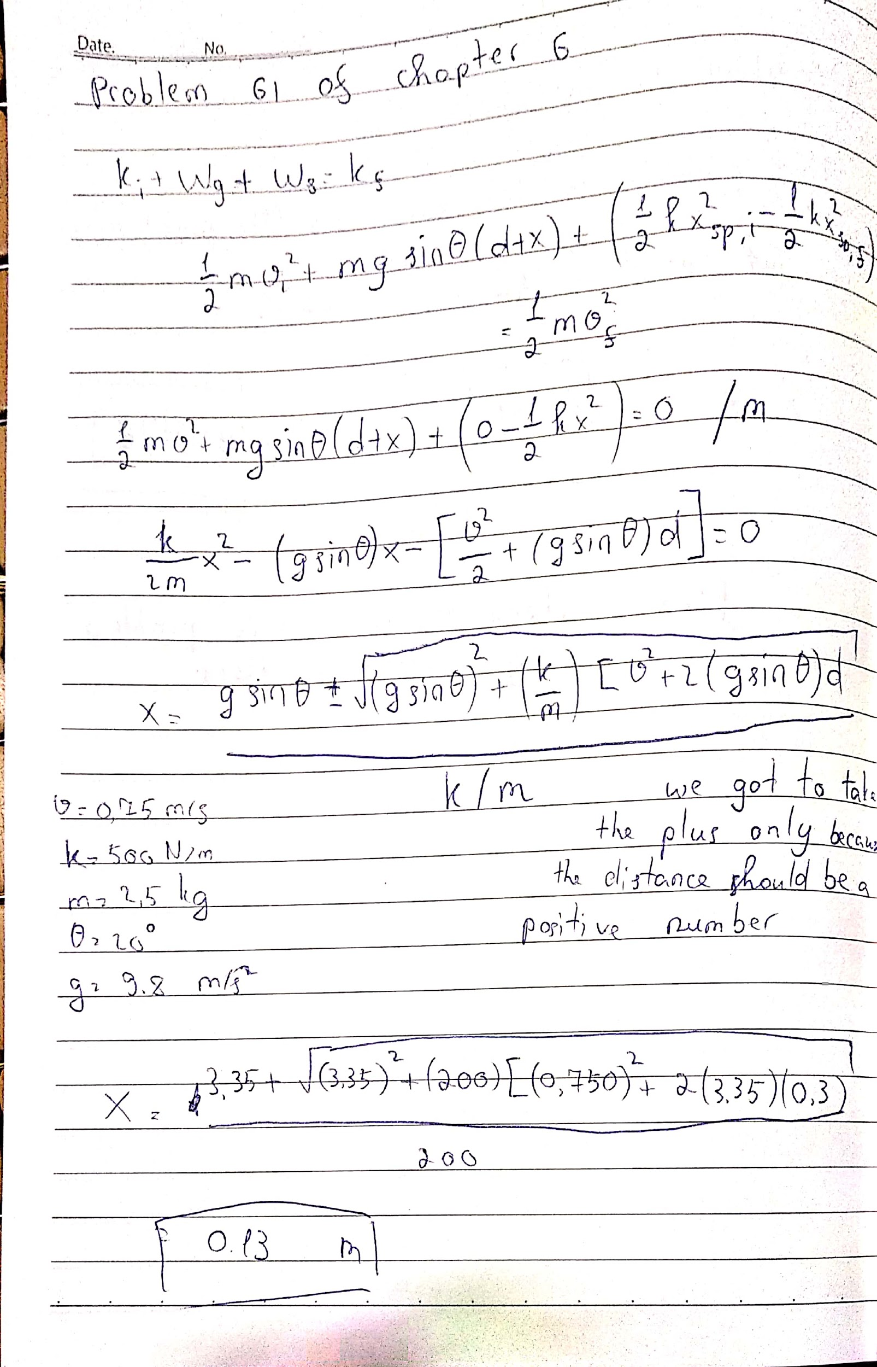

**Problem 62 of chap.6**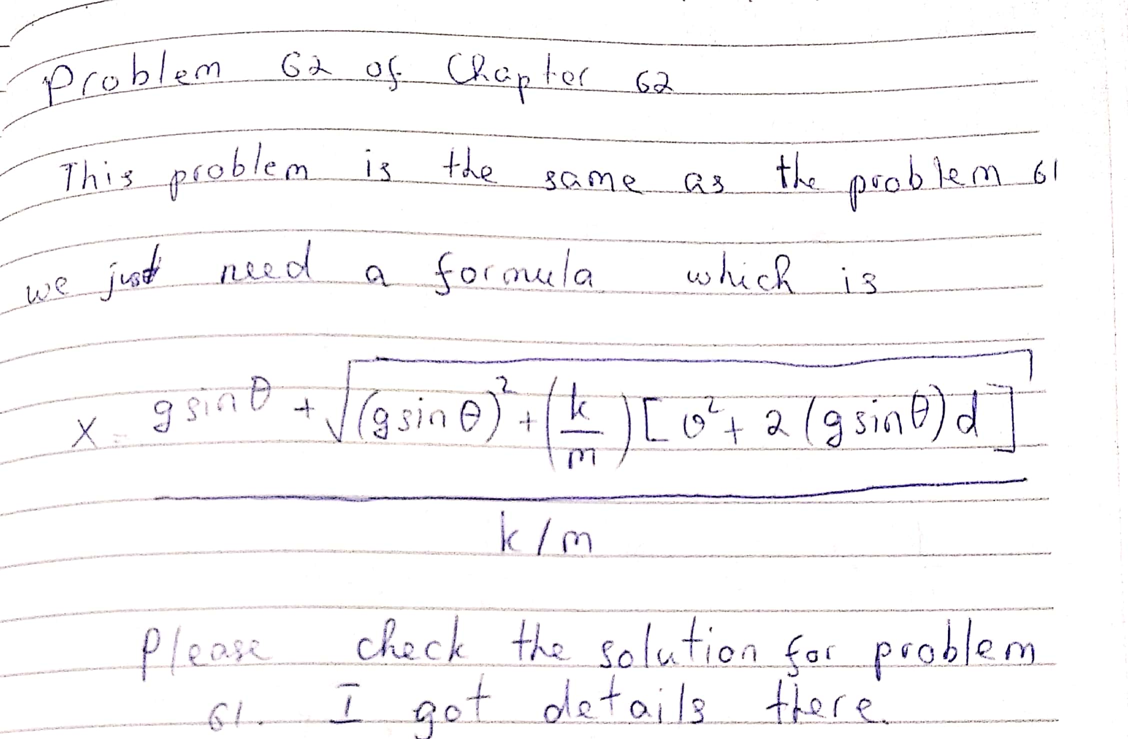

**Thank you**

**Student ID : 201923250**

**Name : Kobilov Ilkhomjon**